1/ Most people will take ___ transportation.
a material b public
1

c spaces d recycle
2/ In the future, electronic ___ will use less energy.
a spreads b spaces
c desserts d goods
3/ People won't use paper ___ very often.
a products b bottle
c cans d spaces
4/ Do you think that oil will be even ___ expensive?
a any b some
c more d many
5/ It sounds like the environment will continue to be ___ danger.
a on b in c at d for
6/ There will be very little oil. So most people will ___.
a ride bikes b take public transportation
c go to desserts d a or b is correct.
7/ With electric energy, we'll have a cleaner ___in 40 years.
a dessert b environment
c affordable d temperature
8/ I look ___ now.
a beautifully b beautiful
c beauty d Both a&b are correct.
9/ Most people will ____ electric cars.
a ride b drive
c space d Both a&b are correct.
10/ We will see ___ cars on the street.
a driverlessly b driveless
c driver d driverless
11/ People won't go shopping in ___. They will shop ___ only.
a spaces - online b shops - stores
c stores – online d online - stores
12/ There ___ a number of organizations that are dedicated to doing something about climate change.
a is b was c be d are
13/ Idle No More is a Canadian organization which ___ formed in 2020.
a was being b did
c was d Both a&b are correct.
14/ The group ___ protests with people all over the country.
a thinks b is c does d holds
15/ 350.org's goal is to unite climate ____ around the world into a larger movement.
a online b activists
c tablets d Both a&b are correct.
16/ I think scientists will discover a ___ for cancer soon.
a tar b cure
c table d solar
17/ I think some diseases will pose a serious danger to the world ___.
a health b continue
c tablets d expertise
18/ We continue to do research and prepare ___ for these challenges.
a ours b our
c ourselves d themselves
19/ The ___ of English helps ideas, products, and information travel from one country to another.
a tablet b tar
c spread d cure
20/ Women are going to have more and ___ opportunities in the future.
a more b less
c worse d much
21/ Anna ___ blue eyes.
a is b does c has d will be
22/ His eyes are ___. They are not exactly green and not exactly brown.
a pinky b hazel
c brunette d blonde
23/ My daughter has red hair, ___ her father.
a is b hazel
c like d Both a&c are correct.
24/ Because of her light hair, Jane is ___.
a a blonde hair b blonde hair
c a blonde d Both a&c are correct.
25/ Uncle Allen is ___ but his son is short.
a tall b long
c short d high
26/ My brother has many friends on Facebook and is very ___.
a smart b popular
c shy d Both a&c are correct.
27/ She's very ___. She always makes me laugh!
a funny b shy
c smart d popular
28/ The salesperson is so ___. She smiles and says hello when I walk in.
a friendly b funny
c popular d shy
29/ What does Kathy look like?
a She is shy but beautiful.
b She is tall and funny.
c She has a short hair and blonde.
d She is slim with curly short black hair.
30/ - What ___ Sara ____? - She's friendly.
a does - look like b does - like
c is – like d is - look like
31/ ___ you have a younger brother?
a Don't b Are
c Aren't d Both a&c are correct.
32/ Have you ever wondered if you had a(n) ___ twin out there somewhere?
a spiky b hazel
c adapted d identical
33/ Amy was ___ when she was a baby.
a added b adaptor
c adapted d adopted
34/ She didn't know anything about her ___ mother or family.
a side b in-law
c birth d project
35/ In college, Amy ___ in a video project for her friend.
a started b starting
c starring d starred
36/ Someone ____ Suzie emailed Amy's friend asking about Amy.
a names b named
c naming d Both a&c are correct.
37/ Amy got ___ Suzie on a social media site.
a in touch with b on touch up
c on up to d put up with
38/ They found down they had both been ___ in New Hampshire and put up for adoption.
a born b boring
c bear d bore
39/ Suzie lived a nice life ___ a family in Hawaii.
a by b at c with d None is correct.
40/ They ___ a video call finally.
a got on b set up
c got up d setted up

1/ His eyes are ___. They are not exactly green and not exactly brown.
2

a pinky b hazel
c blonde d brunette
2/ My daughter has red hair, ___ her father.
a like b hazel
c is d Both a&c are correct.
3/ The new guy at work has ___.
a a short hair b a spiky, short hair
c short, spiky hair d Both a&c are correct.
4/ Raj has medium-____, wavy hair.
a length b long
c longth d Both a&c are correct.
5/ My brother ___ his hair very short.
a does b goes
c works d wears
6/ Uncle Allen is ___ but his son is short.
a high b tall
c short d long
7/ My boss has ____ experience and is very smart.
a a great deal of b many
c much d Both a&c are correct.
8/ My brother has many friends on Facebook and is very ___.
a shy b popular
c smart d Both a&c are correct.
9/ She's very ___. She always makes me laugh!
a funny b popular
c shy d smart
10/ The salesperson is so ___. She smiles and says hello when I walk in.
a popular b shy
c friendly d funny
11/ Even though my brother is funny, he can be very ___ around people he doesn't know well.
a funny b shy
c friendly d popular
12/ What does Kathy look like?
a She is slim with curly short black hair.
b She is shy but beautiful.
c She has a short hair and blonde.
d She is tall and funny.
13/ - What ___ Sara ____? - She's friendly.
a does - look like b is - look like
c is – like d does - like
14/ Have you ever wondered if you had a(n) ___ twin out there somewhere?
a adapted b spiky
c hazel d identical
15/ In college, Amy ___ in a video project for her friend.
a starting b started
c starred d starring
16/ Someone ____ Suzie emailed Amy's friend asking about Amy.
a names b naming
c named d Both a&c are correct.
17/ Amy got ___ Suzie on a social media site.
a put up with b on up to
c in touch with d on touch up
18/ They found down they had both been ___ in New Hampshire and put up for adoption.
a bear b born c boring d bore
19/ Suzie lived a nice life ___ a family in Hawaii.
a at b by
c with d None is correct.
20/ They looked almost exactly the ___.
a like b look like
c same d Both a&c are correct.
21/ His eyes are ___. They are not exactly green and not exactly brown.
a hazel b blonde
c pinky d brunette
22/ My daughter has red hair, ___ her father.
a is b hazel
c like d Both a&c are correct.
23/ Because of her light hair, Jane is ___.
a blonde hair b a blonde
c a blonde hair d Both a&c are correct.
24/ The new guy at work has ___.
a a spiky, short hair b short, spiky hair
c a short hair d Both a&c are correct.
25/ Raj has medium-____, wavy hair.
a long b longth
c length d Both a&c are correct.
26/ My brother ___ his hair very short.
a wears b does c goes d works
27/ Uncle Allen is ___ but his son is short.
a high b long c short d tall
28/ My boss has ____ experience and is very smart.
a much b many
c a great deal of d Both a&c are correct.
29/ My brother has many friends on Facebook and is very ___.
a shy b popular
c smart d Both a&c are correct.
30/ She's very ___. She always makes me laugh!
a popular b shy
c smart d funny
31/ The salesperson is so ___. She smiles and says hello when I walk in.
a friendly b shy
c funny d popular
32/ What does Kathy look like?
a She is shy but beautiful.
b She is slim with curly short black hair.
c She has a short hair and blonde.
d She is tall and funny.
33/ - What ___ Sara ____? - She's friendly.
a is – like b is - look like
c does - look like d does - like
34/ Have you ever wondered if you had a(n) ___ twin out there somewhere?
a spiky b adapted
c hazel d identical
35/ Amy was ___ when she was a baby.
a adapted b adaptor
c adopted d added
36/ She didn't know anything about her ___ mother or family.
a birth b side
c project d in-law
37/ Someone ____ Suzie emailed Amy's friend asking about Amy.
a names b named
c naming d Both a&c are correct.
38/ Suzie lived a nice life ___ a family in Hawaii.
a with b by
c at d None is correct.
39/ They ___ a video call finally.
a set up b got on
c setted up d got up
40/ They looked almost exactly the ___.
a same b look like
c like d Both a&c are correct.

ỦY BAN NHÂN DÂN TP.HCM CỘNG HÒA XÃ HỘI CHỦ NGHĨA VIỆT NAM
TRƯỜNG CĐ LÝ TỰ TRỌNG TPHCM Độc lập – Tự do – Hạnh phúc
********** ******

ĐỀ THI GIỮA HỌC PHẦN LÝ THUYẾT
HỌC KỲ: II NĂM HỌC: 2019 - 2020 Thời gian: 45’
Đề 1

Bậc đào tạo: Học phần:

PHIẾU TRẢ LỜI TRẮC NGHIỆM

TÊN: _________________________________________________________
LỚP: ___________________
Tô đen những câu trả lời đúng bằng bút mực. Mỗi câu chỉ tô 1 đáp án.
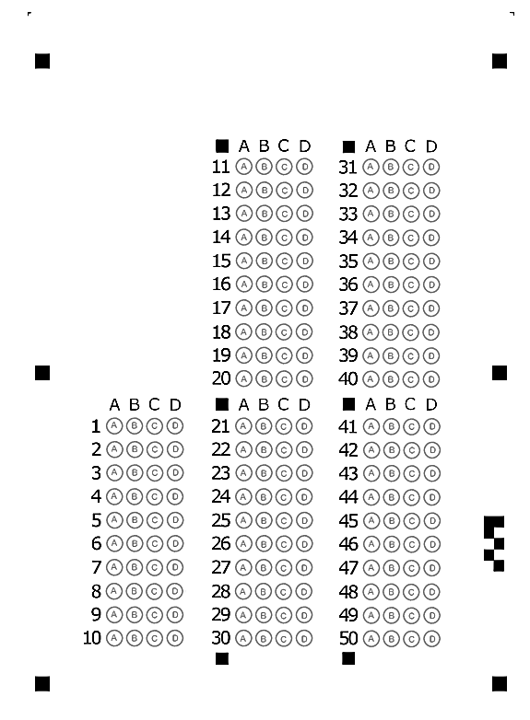
ỦY BAN NHÂN DÂN TP.HCM CỘNG HÒA XÃ HỘI CHỦ NGHĨA VIỆT NAM
TRƯỜNG CĐ LÝ TỰ TRỌNG TPHCM Độc lập – Tự do – Hạnh phúc
********** ******

ĐỀ THI GIỮA HỌC PHẦN LÝ THUYẾT
HỌC KỲ: II NĂM HỌC: 2019 - 2020 Thời gian: 45’
Đề 1

Bậc đào tạo: Học phần:

PHIẾU TRẢ LỜI TRẮC NGHIỆM

TÊN: _________________________________________________________
LỚP: ___________________
Tô đen những câu trả lời đúng bằng bút mực. Mỗi câu chỉ tô 1 đáp án.

¤ Đáp án của đề thi 1:
1[ 1]b... 2[ 1]d... 3[ 1]a... 4[ 1]c... 5[ 1]b... 6[ 1]d... 7[ 1]b... 8[ 1]b...
9[ 1]b... 10[ 1]d... 11[ 1]c... 12[ 1]d... 13[ 1]c... 14[ 1]d... 15[ 1]b... 16[ 1]b...
17[ 1]a... 18[ 1]c... 19[ 1]c... 20[ 1]a... 21[ 1]c... 22[ 1]b... 23[ 1]c... 24[ 1]c...
25[ 1]a... 26[ 1]b... 27[ 1]a... 28[ 1]a... 29[ 1]d... 30[ 1]c... 31[ 1]a... 32[ 1]d...
33[ 1]d... 34[ 1]c... 35[ 1]d... 36[ 1]b... 37[ 1]a... 38[ 1]a... 39[ 1]c... 40[ 1]b...

¤ Đáp án của đề thi 2:
1[ 1]b... 2[ 1]a... 3[ 1]c... 4[ 1]a... 5[ 1]d... 6[ 1]b... 7[ 1]d... 8[ 1]b...
9[ 1]a... 10[ 1]c... 11[ 1]b... 12[ 1]a... 13[ 1]c... 14[ 1]d... 15[ 1]c... 16[ 1]c...
17[ 1]c... 18[ 1]b... 19[ 1]c... 20[ 1]c... 21[ 1]a... 22[ 1]c... 23[ 1]b... 24[ 1]b...
25[ 1]c... 26[ 1]a... 27[ 1]d... 28[ 1]d... 29[ 1]b... 30[ 1]d... 31[ 1]a... 32[ 1]b...
33[ 1]a... 34[ 1]d... 35[ 1]c... 36[ 1]a... 37[ 1]b... 38[ 1]a... 39[ 1]a... 40[ 1]a...

